

NATIONAL INSTITUTE OF TECHNOLOGY KARNATAKA

SURATHKAL, MANGALORE - 575 025

Course Code – CS254

Course Name – Database Systems Lab

Lab - 03

Date – February 9, 2022

Submitted To

Dr. Annappa B

Department of Computer Science and Engineering

National Institute of Technology Karnataka, Surathkal

Submitted By

Md Rakib Hasan

Roll – 201CS132

Department of Computer Science and Engineering

**1. Create a table cust with following columns**

**Cust id as not null,**

**Name**

**Assume appropriate data types.**

CREATE DATABASE lab;

USE lab;

CREATE TABLE cust (

    cust_id INT NOT NULL,

    name VARCHAR(50));

**a. Alter the table cust to add not null constraint to name.**

ALTER TABLE cust

CHANGE name

    name VARCHAR(255) NOT NULL;

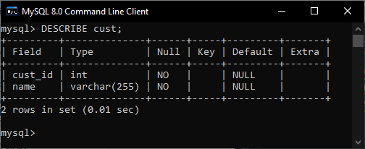

**b. Alter the table cust to add unique constrain to custid.**

ALTER TABLE cust

ADD UNIQUE (cust_id)

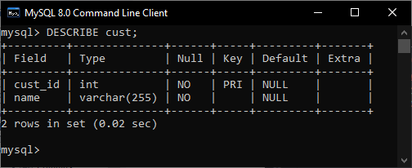

**Create table student with following columns**

**Regno**

**Mark**

**Where mark 0<=mark<=100.**

**Assume appropriate data types.**

CREATE TABLE student (

    regno INT,

    mark INT,

    CHECK (0<=mark<=100));

**a. Alter the student table to add the constraint to check the length of regno is 4.**

ALTER TABLE student

ADD CHECK (LENGTH(regno) = 4)

**Create a table EMP with the following structure.**

**EMPNO NUMBER(6)**

**ENAME VARCHAR(20)**

**JOB VAECHAR(10)**

**DEPTNO NUMBER(3)**

**SAL NUMBER(7,2)**

CREATE TABLE emp (

    emp_no INT,

    ename VARCHAR(20),

    job VARCHAR(10),

    dept_no INT,

    sal INT);

**a. Allow NULL for all columns except ename and job.**

ALTER TABLE emp

CHANGE ename

        ename VARCHAR(20) NOT NULL;

ALTER TABLE emp

CHANGE job

        job VARCHAR(10) NOT NULL;

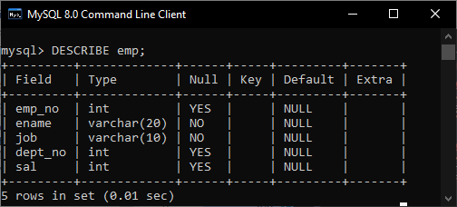

**b. Add a column experience to the emp table. Experience numeric null allowed.**

**Modify the column width of the job field of emp table.**

ALTER TABLE emp

ADD COLUMN experience VARCHAR(20);

ALTER TABLE emp

CHANGE job

    job VARCHAR(20) NOT NULL;

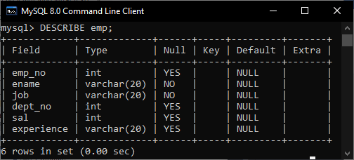

**2. Create table products with following columns.**

**ProductID,**

**ProductName,**

**SupplierID,**

**CategoryID,**

**Unit,**

**Price**

**Assume appropriate data types.**

**Create table customers with the following columns –**

**CustomerID,**

**CustomerName,**

**ContactName,**

**Address,**

**City,**

**PostalCode,**

**Country**

**Assume appropriate data types.**

**Insert at least 10 entries in each table.**

CREATE DATABASE IF NOT EXISTS myshop;

USE myshop;

CREATE TABLE products (

    product_id INT NOT NULL,

    product_name VARCHAR(255),

    supplier_id INT NOT NULL,

    category_id INT NOT NULL,

    unit INT NOT NULL,

    price INT NOT NULL,

    PRIMARY KEY (product_id));

CREATE TABLE customers (

    customer_id INT NOT NULL,

    customer_name VARCHAR(255),

    contact_name VARCHAR(255),

    address VARCHAR(255),

    city VARCHAR(255),

    postal_code INT,

    country VARCHAR(255),

    PRIMARY KEY (customer_id));

INSERT INTO customers

    VALUES (501, "Hasan", "Rakib", "Surathkal", "Mangalore", 575025, "India"),

    (502, "Mr Karim", "Mr Karim", "Surathkal", "UP", 575026, "India"),

    (503, "Rahim", "Rahim Ali", "Surathkal", "Delhi", 575035, "India"),

    (504, "Adnan", "Adnan Rakib", "Surathkal", "Kolkata", 575027, "India"),

    (505, "Kabir", "Kabir Khan", "Surathkal", "Dhaka", 575000, "Bangladesh"),

    (506, "Sohag", "Hafizur", "Surathkal", "Bangalore", 575050, "India"),

    (507, "Tanaf", "Tanzimul", "Surathkal", "San Francisco", 575070, "US"),

    (508, "Smrity", "Ayaan", "Surathkal", "Paris", 575080, "Franch"),

    (509, "Liza", "Liza", "Surathkal", "London", 575029, "India"),

    (510, "Thamina", "Fabiha", "Surathkal", "London", 575075, "UK");

INSERT INTO products

    VALUES (1, "Apple", 101, 1, 50, 18),

    (2, "Orange", 103, 2, 80, 18),

    (3, "Cherry", 104, 3, 10, 32),

    (4, "Strawberry", 107, 44, 50, 44),

    (5, "Grape", 110, 5, 16, 57),

    (6, "Pears", 108, 6, 20, 59),

    (7, "Berries", 109, 7, 25, 70),

    (8, "Melons", 106, 8, 52, 60),

    (9, "Mango", 105, 9, 30, 180),

    (10, "Banana", 102, 27, 50, 10);

**a. Increase the price of all products by 5 and display it as ‘Price+10’ in products table.**

SELECT

    *,

    price*5 AS "price+10"

FROM products

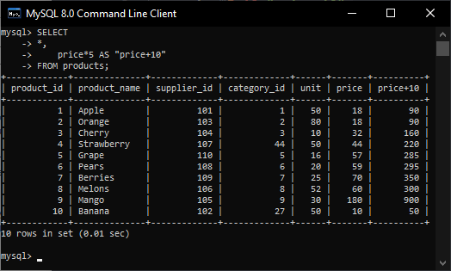

**b. List all the items from products whose price = 18**

SELECT *

FROM products

WHERE price = 18

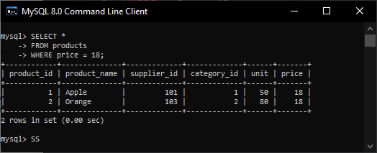

**c. List all the items from products whose price is more then 30**

SELECT *

FROM products

WHERE price > 30

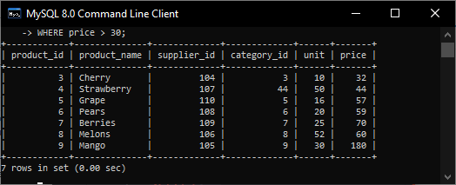

**d. List all the items from products whose price is not equal to 18**

SELECT *

FROM products

WHERE price != 18

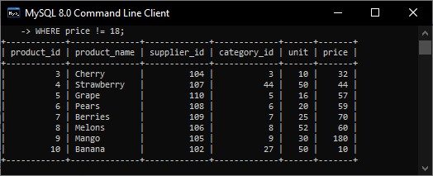

**e. List the items from products whose price is between 50 and 60**

SELECT *

FROM products

WHERE price BETWEEN 50 AND 60

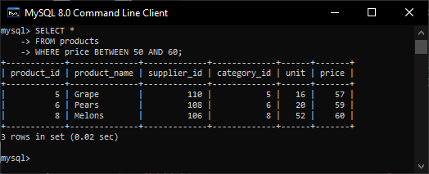

**f. List the customer details from customers whose city is London and country is UK.**

SELECT *

FROM customers

WHERE city = "London" AND country = "UK"

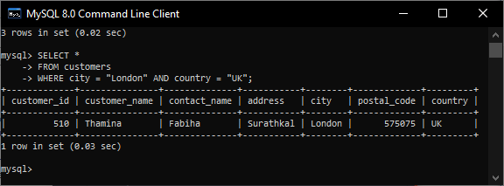

**g. List the customer details from customers whose city is London or country is UK.**

SELECT *

FROM customers

WHERE city = "London" OR country = "UK"

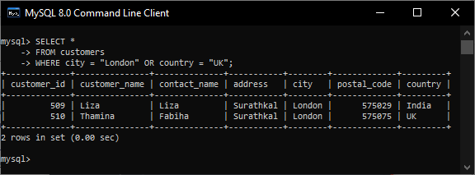

**h. List the customer details from customers whose city matches with the list of cities among Paris, London, San Francisco.**

SELECT *

FROM customers

WHERE city IN ("Paris", "London", "San Francisco")

